# Introduction

## Report Objectives

Key terms and definitions after the above cited reference are presented in Table 1.

Table 1 Glossary: key terms and definitions[1]

|  |
| --- |
| **Alien or non-indigenous species (NIS)** is one that is introduced beyond its original range of distribution. |
| **Ballast water** is taken into the hull of ship to maintain its stability when a ship is not loaded or is only partially loaded. |
| **Ecosystems** is a dynamic complex of plant, animal, and microorganism communities and the nonliving environment interacting as a functional unit. Humans are an integral part of ecosystems. Ecosystems vary enormously in size; a temporary pond in a tree hollow and an ocean basin can both be ecosystems |
| **Fouling (in our book is used as synonym of biofouling)** - means the accumulation of aquatic organisms such as micro-organisms, plants, and animals on surfaces and structures immersed in or exposed to the aquatic environment. |
| **Indigenous species** is an organism, normally observed for a long time in this area (see **Native area**), and where it is embedded in the local ecosystem and its vital activity is constrained by the interaction with other organisms, and these interactions are the product of coevolution |
| **Invasive alien species** is non-indigenous species that may spread rapidly by outcompeting other native plants and animals when they are introduced into a new habitat that lacks controlling factors as determined by natural evolution. |
| **Native area** is an area, where organism (see **Indigenous species)** is normally observed for a long time, and where it is embedded in the local ecosystem and its vital activity is constrained by the interaction with other organisms, and these interactions are the product of coevolution. |
| **Plankton** are organisms inhabiting water, that are unable to propel themselves against a current. Spend the whole life cycle in water column. |
| **Phytoplankton** – small, mostly unicellular, algae forming a vegetable part of plankton |
| **Zooplankton** – animal part of plankton. |
|  |
|  |
|  |
|  |
|  |

# Assessment Methodology

## Overview

Основные логические шаги

## Потенциальные пути заноса чужеродных видов

In the last half of the 20th century, a primary mode of organism transfer in marine systems has been their transportation in the ballast water of ships (Smith et al., 1999[2]). The main source of ballast water, and therefore NIS, are ports, where ballast is taken, when a ship is not loaded or is not fully loaded (Smith et al., 1999; Drake, Lodge, 2004[3]).

Planktonic organisms are transferred in ballast water. Benthic organisms which have long-living planktonic larvae may also be transferred in ballast water (Chu et al., 1997[4]; Deagle et al., 2003[5]). However, there is another way of transportation of benthic organisms – it is biofouling on hulls of ships (Sylvester et al., 2011[6]).

As an example, in 29 November 2020 and 1 February 2021 investigations of ballast water of several ships working in "Utrenniy" terminal area were conducted (Integrated investigations… 2020[7]). 4 ships were surveyed, 2-3 taxons of planktonic organisms were found: *Limnocalanus grimaldii* (Fig. ), *Pseudocalanus* spp., Calanoida nauplii in numbers up to 630 m-3. Many individuals were dead at the moment of sampling (up to 50%). It should be noted, that no NIS were found in ballast water samples in 2020 and 2021. Those were all cargo ships, operating, according to plankton composition, on the local routes. However, on long-distance routes situation may be different.

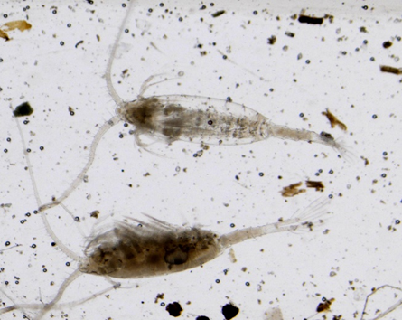

Fig. . *Limnocalanus grimaldii* in samples of ballast water.

In October 2020 investigations of fouling on constructions of terminal "Utrenniy" were conducted as well. No real fouling was observed, because constructions were newly built. In the silt from vertical walls 50 species of microalgae were revealed from 5 taxonomic groups (Bacillariophyta, Cyanophyta, Chlorophyta, Euglenophyta, Cryptophyta). No animals were detected in samples. However, the process of fouling requires some more time, and should be monitored continuously (see Recommendations).

The main prerequisite for successful organism transfer and establishment is similarity of environmental conditions (first of all salinity and temperature) in ports of departure and destination (Smith et al., 1999). Taking this into account, we can analyze potential source ports of NIS for our study area.

The most active traffic on the Northern Sea Route (NSR)as a whole and in the Ob Estuary in particular falls on August and September (Fig. …, … and …; https://arctic-lio.com/category/maps/), when ice extent in the Arctic Ocean is the lowest. The analysis of traffic of the long-distance of LNG tankers from Sabetta has shown that there were 43, 32 and 40 voyages in July, August and September 2021. Other vessels were mostly cargo ships, which operate the most probably on the local routes (inside the Arctic region) and could hardly carry any potential NIS.

More than half of the export shipments in July and August 2021 went eastward – to China, Japan and South Korea (8 shipments out of 14), and 6 vessels went to Europe – to the Netherlands, Spain, Portugal and France (<https://arctic-lio.com/>). In 2020 main destination of LNG and gas condensate were European ports: Belgium (62 voyages), France (58), Netherlands (26), Spain (30), UK (22). There were 25 voyages in China.

The most likely rout for NIS transfer is the western one, because all destination ports in Asia are situated further south than European ones. The most probable candidate are Netherlands as the most northward location. Therefore, we should concentrate on organisms, which are documented as numerous and spreading their range in the northern Europe.

We should keep in mind the increase of voyage number during the last three years and very probable preservation of this trend in future, which means increase of NIS load in the area of interest.

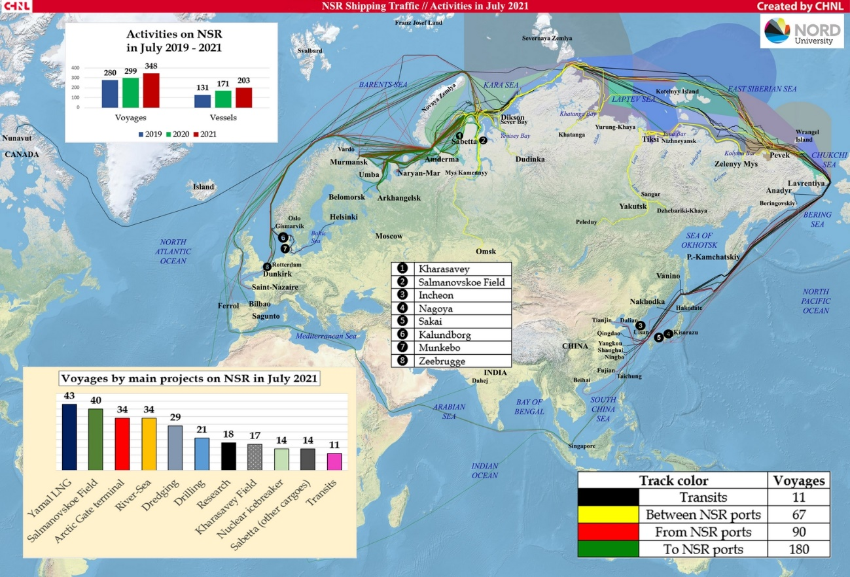

Fig. … Routes of vessels moving to and from terminals (existing and under construction) Ob Estuary in August 2021.

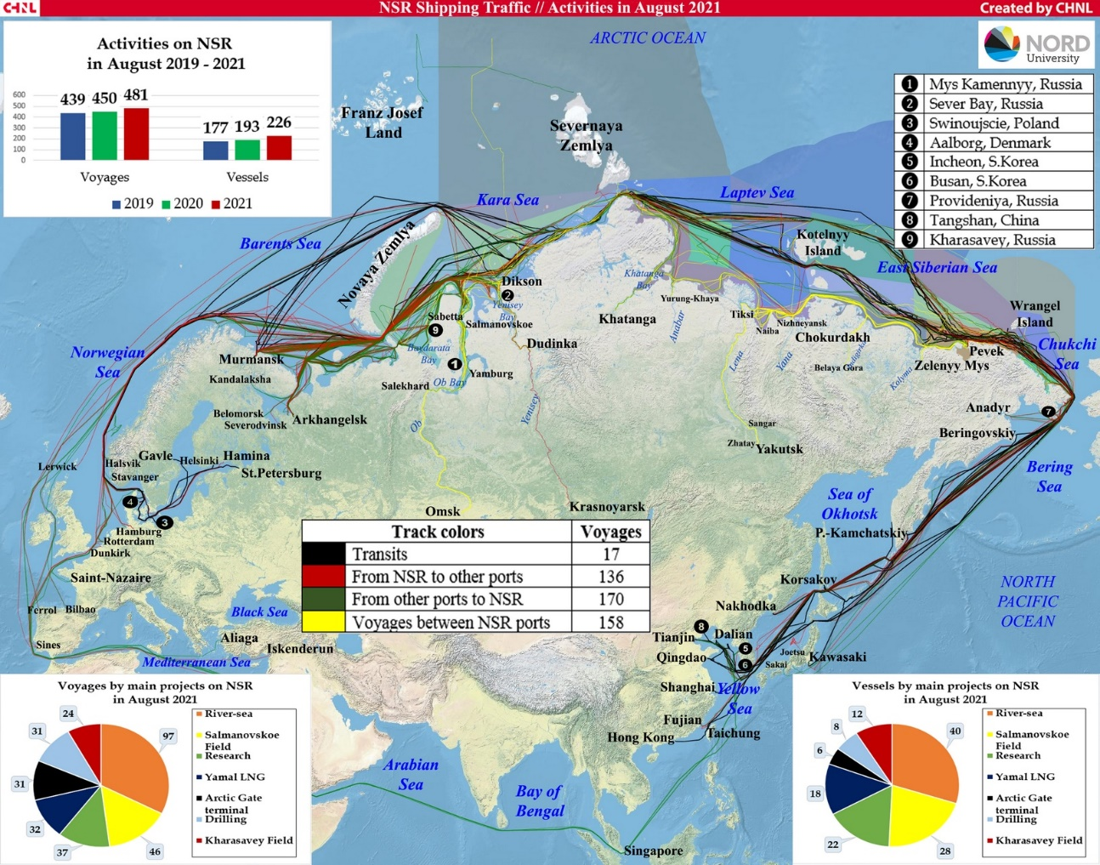

Fig. … Routes of vessels moving to and from terminals (existing and under construction) Ob Estuary in August 2021.

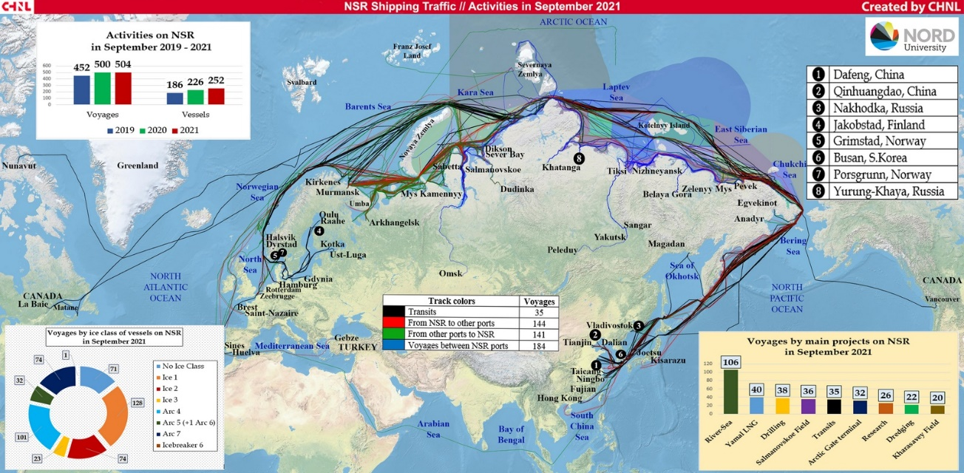

Fig. … Routes of vessels moving to and from terminals (existing and under construction) Ob Estuary in September 2021.

MNK – надо описать схему поступления диаспор с травосмесями. Какие еще пути есть – техника с немытыми колесами? Грязные ботинки и пр.

## Источники информации и их анализ

Надо очень подробно описать, откуда берем данные, как анализируем.

Table 2.1: Significance of the [Пример оформления таблицы]

| No. | Criterion | Significance | Description |
| --- | --- | --- | --- |
| 1 | Uniqueness or rarity | High | The area is the biggest estuary system in the Arctic, affecting the entire adjacent marine ecosystem of the Kara Sea. The huge river run-off has a great impact on the Arctic Ocean, influencing hydrology, ice regime and geochemistry. Some populations of semi-anadromous fish are particular to this area, i.e., Ob Sturgeon, but there are no endemic species of fish, seabirds or marine mammals. |
| 2 | Special importance for species development cycle stages | High | Estuaries are important staging areas for aquatic birds, important habitat for white fishes (feeding, migrating, wintering); the maritime zone, with recurring polynya, is an important spawning area for polar cod (*Boreogadus saida*), while the fast ice in the gulfs is a breeding ground for ringed seals. |
| 3 | Importance for threatened, endangered or declining species and/or habitats | Medium | Important summer feeding grounds for beluga whales (IUCN near threatened), important staging areas for long-tailed duck (IUCN, VU), velvet scoters (IUCN, VU) and Steller’s eiders (IUCN VU). Polar bears (IUCN VU) occur in the outer part of the area. |
| 4 | Vulnerability, fragility, sensitivity, or slow recovery | Medium | The dynamic hydrological regime acts as a buffer for many external impacts; animals such sea ducks and white fishes have long life expectancy and low reproductive rates, thus slow recovery rate; sea ducks and polar cod fry are particularly vulnerable to oil spills, while the estuarine ecosystem in general may be vulnerable to changes in the salinity regime caused by large-scale bar dredging for port construction |
| 5 | Biological productivity | High | Owing to high primary production at the frontal zones the area supports large stocks of freshwater and semi-anadromous fishes, aquatic birds and waterfowl |
| 6 | Biological diversity | Low | Biodiversity of the lower trophic levels is relatively low due to a variable hydrological regime and vast zone of brackish waters; however, there are remarkable gradients towards offshore areas while waterfowl and shorebirds are relatively diverse. |
| 7 | Naturalness | Medium | The Yenisei river estuary is rather pristine while Ob Gulf is already experiencing shipping traffic, geological explorations and onshore infrastructure construction in several points. Rivers bring considerable amounts of pollutants (on the Arctic scale) from their vast watersheds. |

The middle part of the Ob Estuary referred to as the Ob-Taz area (see Figure 2.6) is considered as a priority fishery conservation area (FCA) due to the high concentration of fish of many species during wintering and spawning, including Siberian sturgeon, which is listed as globally Endangered on the IUCN Red List (Matkovsky et al., 2014)[8]. [Примеры ссылок на литературу]

The above areas with high-value biodiversity components are shown in Figure 2.6.

|  |  |
| --- | --- |
|  |  |

Figure 2.6: Water areas of the high environmental value in the Project area [Пример рисунка]

Надо описать весь подход к статистике. Какие пакеты в R используем

Нам надо придумать некую общую балльную оценку потенциальной значимости.

# Assessment Results

## Marine Ecosystems

### Ichthyofauna

Везде делаем краткие локальные выводы, чтобы из них собрать общее заключение

### **Plankton**

**Phytoplakton**

***Prorocentrum cordatum* (Ostenfeld) J.D.Dodge, 1976**

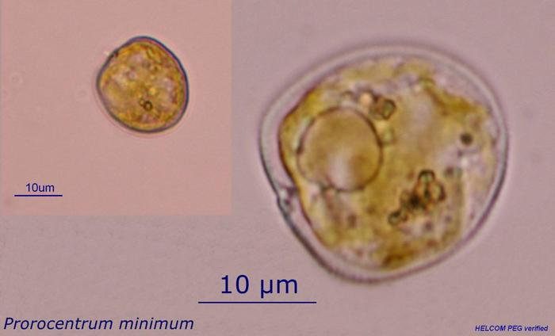

*P. cordatum (minimum*) (Dinophyceae) was introduced in the Baltic Sea and caused recognizable environmental effect (Olenina et al., 2010[9]). This species has wide salinity and temperature tolerance and low-light adaptation (Tyler, Seliger, 1981[10]; Hajdu et al., 2005[11]). P. minimum was found also in the White Sea (Ilyash et al., 2018[12]; GBIF, 2021[13]), which proves it to be eurybiotic species. Is one of the red-tide-forming toxic species (Heil et al., 2005[14]). Being introduced into Ob Estuary *P. cordatum* may cause poisoning of the local aquatic organisms, especially in case of intensive warming. Besides that, may occupy spatial niches of native planktonic algae.

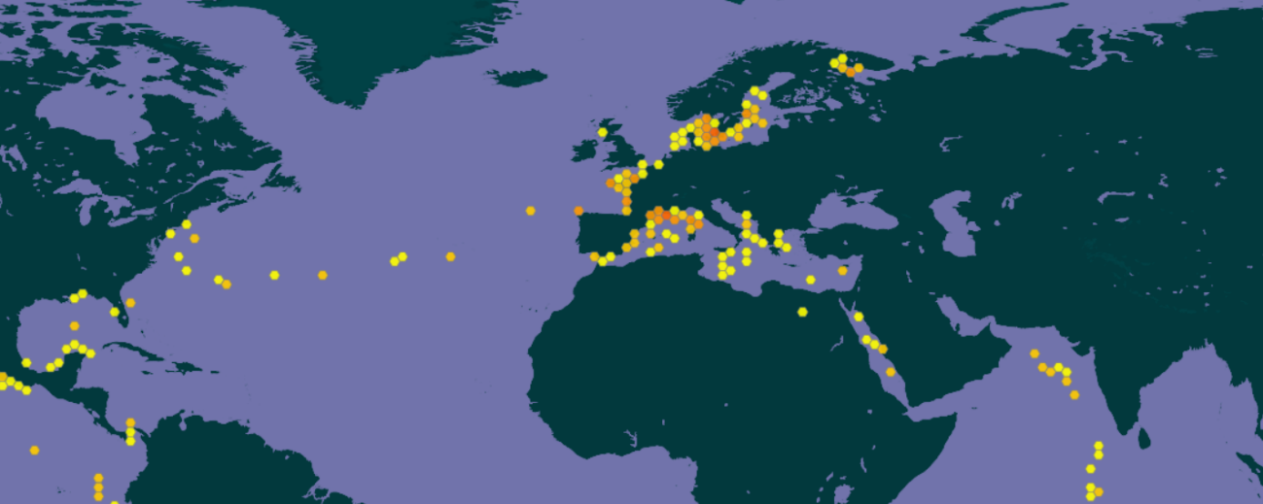

**Ob Estuary**

Fig. . Documented distribution of *Prorocentrum cordatum*.

__________________

***Acanthocyclops robustus* (Sars G.O., 1863)**

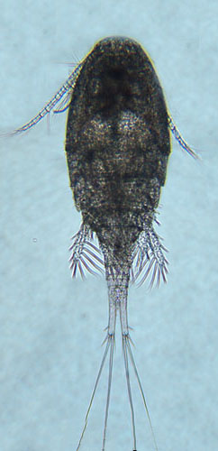

*A. robustus* (Copepoda, Cyclopoida) is temperate freshwater species, which is numerous in European lakes, ponds and estuaries (Purasjoki, Viljamaa, 1984[15]; Marques et al., 2006[16]; Gonçalves et al., 2012[17]). This species dominates in the freshwater zone of Schelde estuary (Belgium, Netherlands), which is strongly influenced by human activity and characterized by a high load of organic matter as well as toxic substances (Tackx et al., 2004[18]). This species was found to be little affected by environmental gradients, so it must be capable to establish in areas with high variability of environmental parameters, which is typical for Ob Estuary. *A. robustus* was also regularly documented near Helsinki, in area, highly affected by human activity (Purasjoki, Viljamaa, 1984). *A. robustus* was documented in waters along Norwegian coast up to Kola peninsula (GBIF, 2021; Fig. ). This predator, being established, could affect local ecosystem, feeding on local organisms, which do not have behavioral adaptations to this new species. In a perspective, this invasion can lead to significant decrease of populations of prey organisms (Rotifera and small Diplostraca).

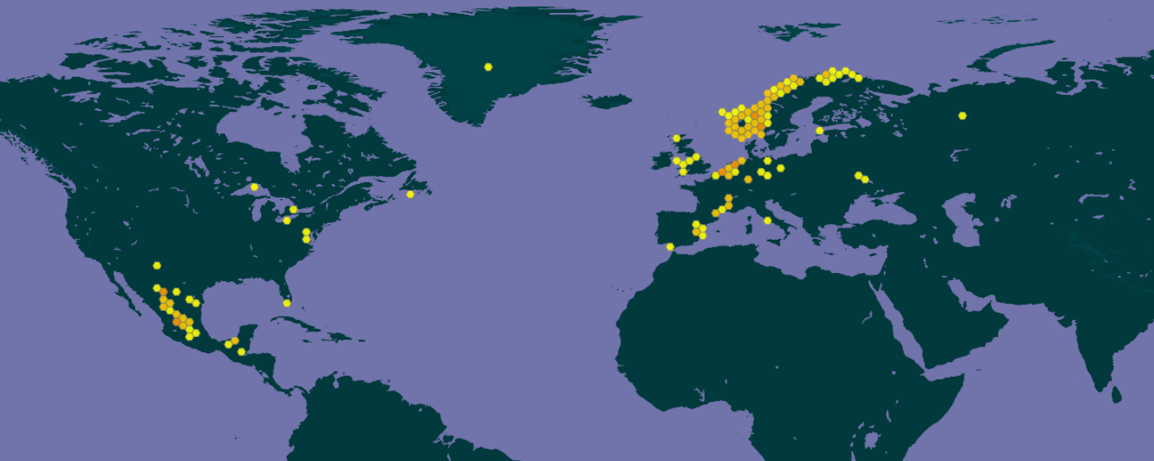

**Ob Estuary**

Fig. . Documented distribution of *Acanthocyclops robustus*.

___________________________

***Acartia (Acanthacartia) bifilosa* (Giesbrecht, 1881)**



*A. bifilosa* (Copepoda, Calanoida) is eryhaline species inhabiting estuaries in the Western Europe (Belgiun, Netherlands), is constituent of brakish-water-marine group in winter-spring (Sautour, Castel, 1995[19]). May survive salinities down to 6-12 psu and temperatures down to 0°C. Was found in estuaries of the northern Europe (GBIF, 2021; Fig. ) A. bifilosa is normal component of the summer planktonic community in the White Sea, prefers waters with low salinities in estuaries (Prudkovsky, 2003 ). A. bifilosa lays resting eggs to survive unfavourable conditions. The latter fact may facilitate transfer of this species in ballast waters. A. bifilosa is basically herbivorous species, which is capable to feed on animal preys, when phytoplankton is scarce (Martynova et al., 2011[20]). This may lead to competitive pressure of this species on local herbivorous organisms, and negative changes in populations of the latter.

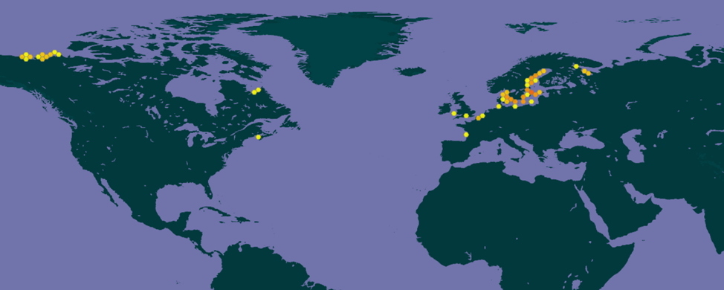

**Ob Estuary**

Fig. . Documented distribution of *Acartia bifilosa*.

### Benthos

### Conclusions

Planktonic (and benthic) communities in the Ob Estuary are exposed to increasing load of alien species brought here from ports of Europe and Asia mostly by LNG and oil tankers either in ballast water (planktonic and benthic organisms) or outside, on ship hulls as fouling (only benthic organisms).

The most probable way of introduction of planktonic NIS is from European ports. The search for potential invasive species has shown that very few organisms have potential to survive and thrive in harsh environments of the Ob Estuary. There are only two planktonic animals and one algae species. Probable impact on local ecosystem include direct predation on local animals (*Acanthocyclops robustus*), competition with them for food (*Acartia bifilosa*), competition for nutrients and light and toxic effect (*Prorocentrum cordatum*). Introduction of any of these species may theoretically lead to negative consequences for local communities. Nevertheless, harsh environment imposes constraints on ability of any alien species to succeed in this area, in the present climatic conditions. However, climate change may facilitate successful establishment of mentioned NIS.

## Terrestrial Realms

### Plants

### Conclusions

# recommendations

**Monitoring recommendations: where (terminals, points of ballast water discharge) and**

**how often (plankton and benthos need different frequency of monitoring). Management**

**recommendations**

Краткий текст, структурированный по объектам (планктон, бентос и пр.), сделаем общую таблицу со всех предложений

**Plankton**

Management of biological invasions consists naturally of two parallel processes: monitoring (to reveal appearance of potential NIS) and prevention of introduction in local environment.

Monitoring of plankton for organisms, potential NIS should be conducted in ballast water itself, immediately on a ship, to assess risk of introducing NIS, i.e. evaluate abundance of potential invasive species, and to assess compliance with ballast water management requirements (David, Perkovič, 2004[21]).

The monitoring of plankton should be undertaken simultaneously in places of ballast water discharge and near terminals to undertake any administrative action (e.g. ban on ballast water discharge in an area). The frequency of monitoring must depend on intensity of traffic and should not be rarer than once a week to reveal alien species before it gets established in local ecosystem.

However, these measures are useless without effective management of ballast water in destination port. The first and the most important step to prevent introduction of nonindigenous species should be prevention of their leaving the ballast tanks of arriving ships. This may be accomplished by various ballast water management systems, mounted on a ship, or could be solved by ballast water discharge in area where salinity and (most probably) temperature differ significantly from exit port (Simard et al., 2011[22]), in open sea area in case of Ob Estuary.

# Conclusion

The total traffic has been increasing for the last three years, and this tendency will remain in future, because of development of new projects. The number of long-distance voyages will rise significantly as new fields and terminals are put into operation. So the load of alien species will increase and probability of introduction invasive species will increase as well. However, we can prevent introduction by monitoring plankton and benthos and take effective measures to treat ballast water and fouling.

# Annex 1. LISTS with non-native species

1. International Finance Corporation’s Guidance Note 6: Biodiversity Conservation and Sustainable Management of Living Natural Resources January 1, 2012 (updated June 27, 2019) and "Millennium Ecosystem Assessment". www.millenniumassessment.org. Archived from the original on 24 February 2018. Retrieved 28 April 2018 with addition [Вот так цитируется литература – при первом упоминании в сноску, далее (Автор, год) ]
2. Smith D.L., Wonham M.J., McCann L.D. Ruiz G.M., Hines A.H., Carlton J.T. (1999) Invasion Pressure to a Ballast-flooded Estuary and an Assessment of Inoculant Survival. Biological Invasions 1: 67–87. https://doi.org/10.1023/A:1010094527218
3. Drake J.M., Lodge D.M. (2004) Global hot spots of biological invasions: evaluating options for ballast–water management Proceedings of the Royal Society of London B. 271: 575–580. http://doi.org/10.1098/rspb.2003.2629
4. Chu K.H., Tam P.F., Fung C.H., Chen Q.C. (1997) A biological survey of ballast water in container ships entering Hong Kong. In: Wong YS., Tam N.FY. (eds) Asia-Pacific Conference on Science and Management of Coastal Environment. Developments in Hydrobiology, vol 123. Springer, Dordrecht. https://doi.org/10.1007/978-94-011-5234-1_20
5. Deagle B.E., Bax N., Hewitt C.L., Patil J.G. (2003) Development and evaluation of a PCR-based test for detection of Asterias (Echinodermata: Asteroidea) larvae in Australian plankton samples from ballast water. Marine and Freshwater Research 54, 709-719.
6. Sylvester F., Kalaci O., Leung B., Lacoursière-Roussel A., Clarke Murray C., Choi F.M., Bravo M.A., Therriault T.W., MacIsaac H.J. (2011) Hull fouling as an invasion vector: can simple models explain a complex problem? J Appl Ecol 48:415–423. doi:10.1111/j.1365-2664.2011.01957.x.
7. Integrated investigations of ecological conditions in the Ob Estuary in the area of potential influence of the Progect "Arctic LNG 2" and on the adjacent area. 2020
8. A. K. Matkovsky, P. A. Kochetkov, B. V. Stepanova, S. I. Stepanov. Ecological rationale for the creation of a fishery conservation area and reduction of anthropogenic load on the ecosystem of the Ob-Taz estuarian zone // Fishery Sciene Bulletin. 2014. Vol. 1. No. 2. pp. 12-26. [In Russian]
9. Olenina I., Wasmund N., Hajdu S., Jurgensone I., Gromisz S., Kownacka J., Toming K., Vaiciūtė D., Olenin S. (2010) Assessing impacts of invasive phytoplankton: The Baltic Sea case. Marine Pollution Bulletin, 60(10): 1691-1700. https://doi.org/10.1016/j.marpolbul.2010.06.046.
10. Tyler, M.A., Seliger, H.H., 1981. Selection for a red tide organism: physiological responses to the physical environment. Limnol. Oceanogr. 26, 310–324.
11. Hajdu S., Pertola S., Kuosa H. (2005) Prorocentrum minimum (Dinophyceae) in the Baltic Sea: morphology, occurrence—a review. Harmful Algae, 4(3): 471-480. https://doi.org/10.1016/j.hal.2004.08.004
12. Ilyash L.V., Belevich T.A., Zhitina L.S., Radchenko I.G., Ratkova T.N. (2018) Phytoplankton of the White Sea. In: Lisitsyn A., Gordeev V. (eds) Biogeochemistry of the Atmosphere, Ice and Water of the White Sea. The Handbook of Environmental Chemistry, vol 81. Springer, Cham. https://doi.org/10.1007/698_2018_320
13. GBIF Secretariat (2021). GBIF Backbone Taxonomy. Checklist dataset https://doi.org/10.15468 accessed via GBIF.org on 2022-01-15.
14. Heil C.A., Glibert P.M., Fan C. (2005) Prorocentrum minimum (Pavillard) Schiller: A review of a harmful algal bloom species of growing worldwide importance. Harmful Algae, 4(3): 449-470. https://doi.org/10.1016/j.hal.2004.08.003.
15. Purasjoki K., Viljamaa H. (1984) Acanthocyclops robustus (Copepoda, Cyclopoida) in plankton of the Helsinki Sea area, and a morphological comparison between A. robustus and A. vernalis. Finnish Marine Research No. 250: 33—44.
16. Marques S.C., Azeiteiro U.M., Marques J.C., Neto J.M., Pardal M.Â. (2006) Zooplankton and ichthyoplankton communities in a temperate estuary: spatial and temporal patterns. Journal of Plankton Research, 28(3): 297–312. https://doi.org/10.1093/plankt/fbi126
17. Gonçalves A.M.M., Pardal M.Â., Marques S.C., Mendes S., Fernández-Gómez M.J., Galindo-Villardón M.P., Azeiteiro U.M. (2012) Responses of Copepoda Life-History Stages to Climatic Variability in a Southern-European Temperate Estuary. Zoological Studies 51(3): 321-335.
18. Tackx L.M.M., de Pauw N., Riet van Mieghem, F. Azémar, Abdelhacq Hannouti, Stefan van Damme, Frank Fiers, Nanette Daro, Patrick Meire (2004) Zooplankton in the Schelde estuary, Belgium and The Netherlands. Spatial and temporal patterns. Journal of Plankton Research, 26(2): 133–141, https://doi.org/10.1093/plankt/fbh016
19. Sautour, B., Castel, J. (1995) Comparative spring distribution of zooplankton in three macrotidal European estuaries. Hydrobiologia 311, 139–151. https://doi.org/10.1007/BF00008577
20. Martynova D.M., Kazus N.A., Bathmann U.V., Graeve M., Sukhotin A.A. (2011) Seasonal abundance and feeding patterns of copepods Temora longicornis, Centropages hamatus and Acartia spp. in the White Sea (66°N). Polar Biol 34: 1175–1195. https://doi.org/ 10.1007/s00300-011-0980-7
21. David M., Perkovič M., (2004) Ballast water sampling as a critical component of biological invasions risk management, Marine Pollution Bulletin, Volume 49, Issue 4, Pages 313-318. https://doi.org/10.1016/j.marpolbul.2004.02.022.
22. Simard N., Plourde S., Gilbert M., Gollasch S. (2011) Net efficacy of open ocean ballast water exchange on plankton communities. Journal of Plankton Research, 33(9): 1378–1395. https://doi.org/10.1093/plankt/fbr038